**Practical No.4**

* **Working with multiple activities (Intent).**

MainActivity.kt:-

package com.example.myapplication  
  
import android.annotation.SuppressLint  
import android.content.Intent  
import androidx.appcompat.app.AppCompatActivity  
import android.os.Bundle  
import android.widget.Button  
  
class MainActivity : AppCompatActivity() {  
 @SuppressLint("MissingInflatedId")  
 override fun onCreate(savedInstanceState: Bundle?) {  
 super.onCreate(savedInstanceState)  
 setContentView(R.layout.*activity_main*)  
  
 var btn1: Button =findViewById(R.id.*nxt*)  
  
 btn1.setOnClickListener **{** var in1:Intent=Intent("com.example.myapplication.IntentApp2")  
 startActivity(in1)  
 **}** }  
}

IntentApp2.kt

package com.example.myapplication  
  
import android.annotation.SuppressLint  
import androidx.appcompat.app.AppCompatActivity  
import android.os.Bundle  
import android.widget.Button  
  
class IntentApp2 : AppCompatActivity() {  
 @SuppressLint("MissingInflatedId")  
 override fun onCreate(savedInstanceState: Bundle?) {  
 super.onCreate(savedInstanceState)  
 setContentView(R.layout.*activity_intent_app2*)  
  
 var btn2:Button=findViewById(R.id.*prv1*)  
 btn2.setOnClickListener **{** finish()  
 **}** }  
}

AndroidMainfest.xml

*<?*xml version="1.0" encoding="utf-8"*?>*<manifest xmlns:android="http://schemas.android.com/apk/res/android"  
 xmlns:tools="http://schemas.android.com/tools">  
  
 <application  
 android:allowBackup="true"  
 android:dataExtractionRules="@xml/data_extraction_rules"  
 android:fullBackupContent="@xml/backup_rules"  
 android:icon="@mipmap/ic_launcher"  
 android:label="@string/app_name"  
 android:supportsRtl="true"  
 android:theme="@style/Theme.MyApplication"  
 tools:targetApi="31">  
 <activity  
 android:name="com.example.myapplication.IntentApp2"  
 android:exported="true">  
 <intent-filter>  
 <action android:name="com.example.myapplication.IntentApp2" />  
  
 <category android:name="android.intent.category.DEFAULT" />  
 </intent-filter>  
 </activity>  
 <activity  
 android:name=".MainActivity"  
 android:exported="true">  
 <intent-filter>  
 <action android:name="android.intent.action.MAIN" />  
  
 <category android:name="android.intent.category.LAUNCHER" />  
 </intent-filter>  
 </activity>  
 </application>  
  
</manifest>

OUTPUT :-

* Starting of the app (MainActivity.kt) :-

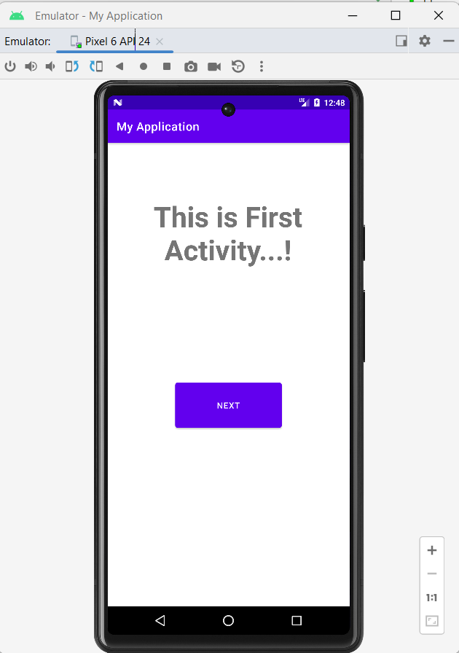

* Navigating to second activity on button (NEXT) click :-

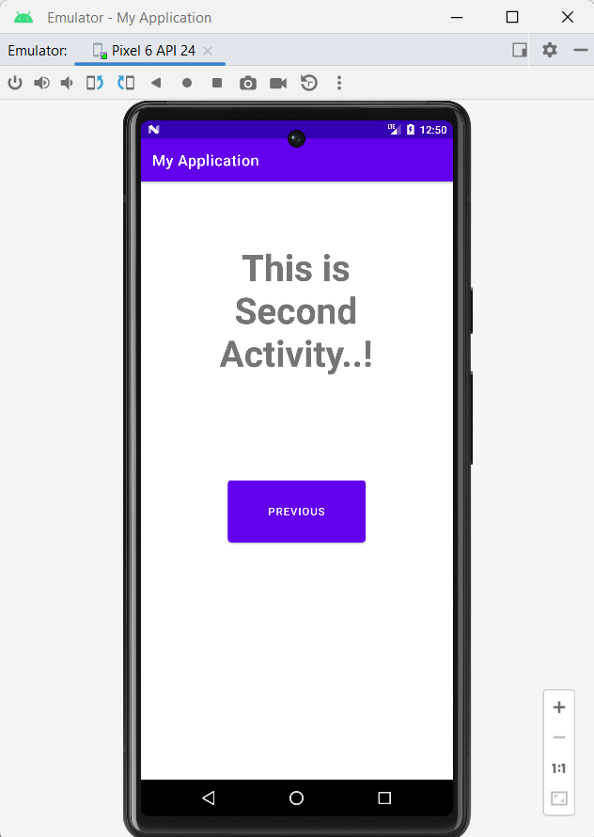

* Navigating to second activity on button (PREVIOUS) click:-

